Project Development Phase
Model Performance Test

Date | 17 February 2026
Team ID | LTVIP2026TMIDS54366
Project Name | PROSPERITY PROGNOSTICATOR: MACHINE LEARNING STARTUP SUCCESS PREDICTION
Maximum Marks

Model Performance Testing:
Project team shall fill the following information in model performance testing template.
S.No. | Parameter | Values | Screenshot
 | Model Summary | Machine Learning–based Startup Success Prediction System (Prosperity Prognosticator) that predicts whether a startup will be acquired or closed using historical funding, milestone, and relationship data.  The system uses a Random Forest model integrated with a Flask web application to provide real-time predictions for investors and startup founders. | 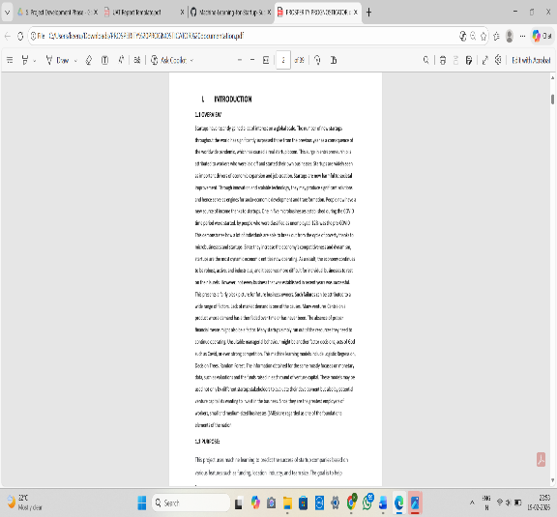
 | Accuracy | Training Accuracy - 100%  Validation Accuracy – 80% | 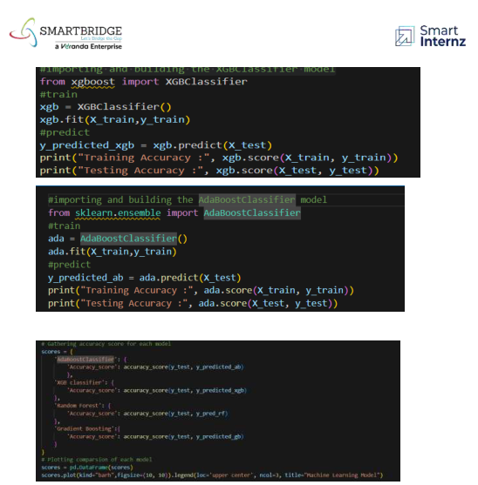
3. | Fine Tunning Result  ( if Done) | Validation Accuracy - The Random Forest model was evaluated and showed overfitting, with 100% training accuracy and 80% test accuracy. Hyperparameter tuning and model evaluation techniques were applied to improve generalization and reduce overfitting, resulting in a stable prediction performance of 80% validation accuracy. | 